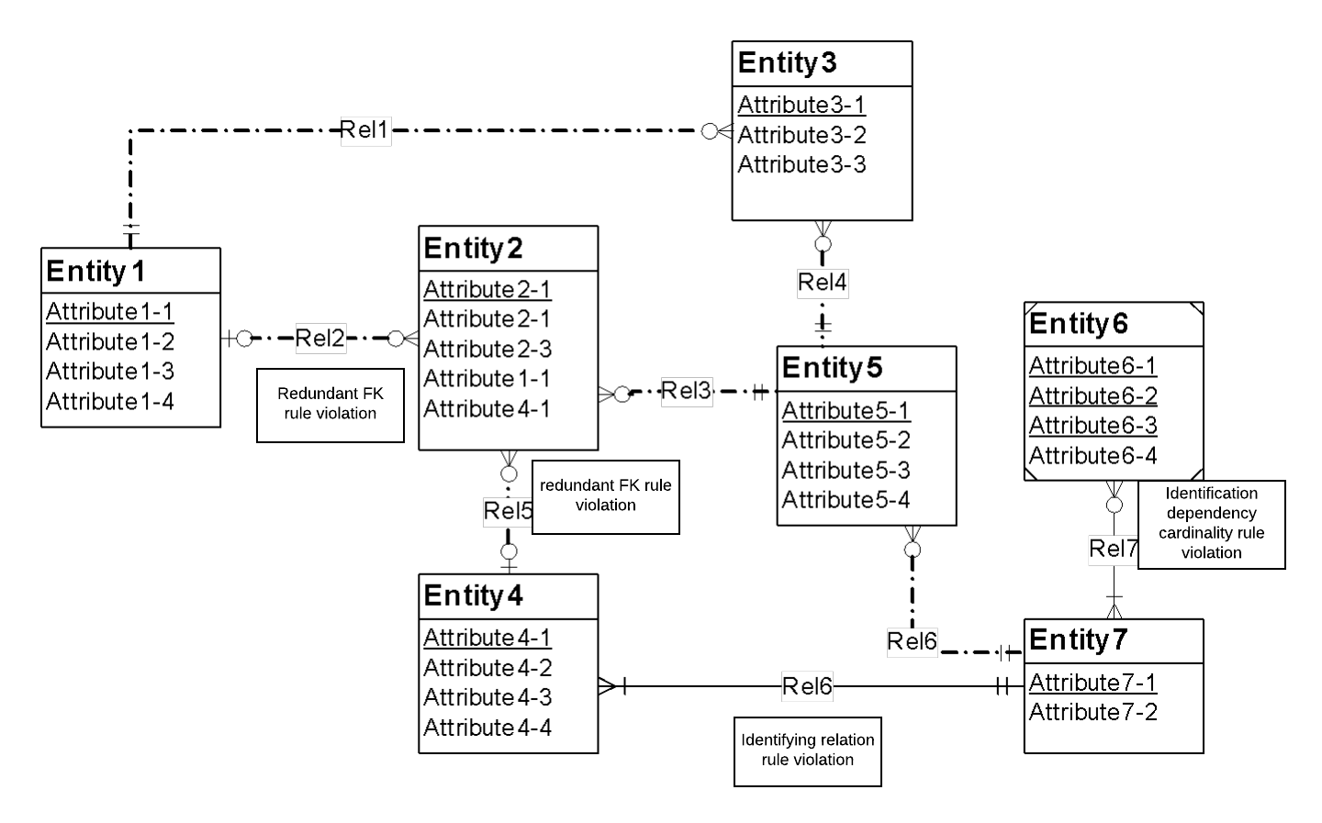

The following list identifies possible ways to fix the diagram errors:

* Resolution of the redundant FK rule: Normally the problem can be resolved by removing the redundant foreign keys (Entity2.Attribute4-1 and Entity2.Attribute1-1). If the attribute does not represent a foreign key, it should be renamed instead of removed.
* Resolution of the identification dependency cardinality rule: The problem can be resolved by changing the weak entity’s cardinality in Rel7 to (1,m).
* Resolution of the identifying relationship rule: The problem can be resolved by adding one or more weak entities or making the relationship (Rel6) non-identifying.

**Corrected ER -Diagram**

